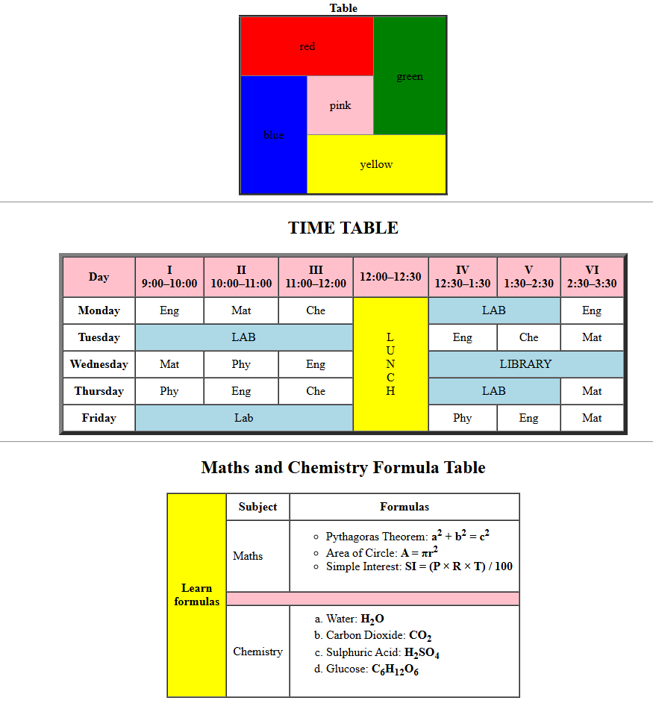

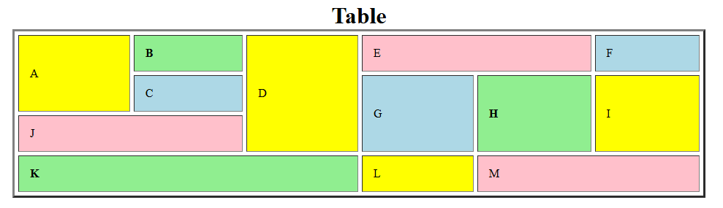

Design an HTML table for LJ University - Student List that displays the Branch, Student Name, and Roll Number of students.
The table should:
- Use the rules="groups" attribute so that horizontal lines are drawn only between row groups (different branches).
- Include at least two different branches (e.g., Computer Science, Mechanical).
- Each branch should have multiple students, and the branch name should span multiple rows using the rowspan attribute.
- Add a table header (<thead>) with column titles (Branch, Student Name, Roll Number).
- Add a footer row (<tfoot>) with copyright information for LJ University.
- Show background color for different row groups (<tbody>) so that each branch is visually distinct.
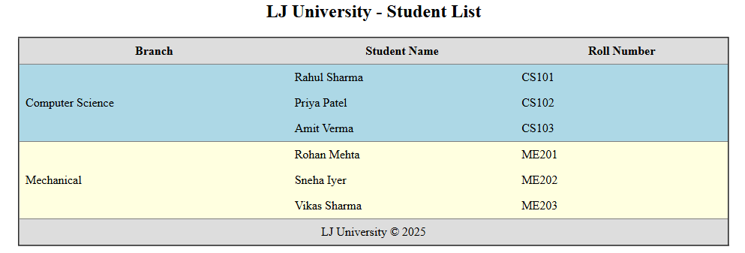

Example
